Name : Khush Pithva 24BCE174
Subject : Data Structure (2CS501)
Practical no.: 3A
AIM : Create Stack data structure using Array and implement following functions:
i. Push ii. Pop iii. Peek

INPUT :
#include <bits/stdc++.h>
using namespace std;

#define MAX 100
int arr[MAX];
int top = -1;

void push(int value)
{
if (top == MAX - 1) {
cout << "Stack Overflow!" << endl;
} else {
top++;
arr[top] = value;
cout << value << " pushed." << endl;
}
}

void pop() {
if (top == -1) {
cout << "Stack Underflow!" << endl;
} else {
cout << arr[top] << " popped." << endl;
top--;
}
}

void peek() {
if (top == -1) {
cout << "Stack is Empty!" << endl;
} else {
cout << "Top element: " << arr[top] << endl;
}
}

void display() {
if (top == -1) {
cout << "Stack is Empty!" << endl;
} else {
cout << "Stack elements (top to bottom): ";
for (int i = top; i >= 0; i--) {
cout << arr[i] << " ";
}
cout << endl;
}
}

int main() {
int choice, value;

do {
cout << "\n--- Stack Menu ---\n";
cout << "1. Push\n2. Pop\n3. Peek (Top)\n4. Display\n5. Exit\n";
cout << "Enter choice: ";
cin >> choice;

switch (choice)
{
case 1:
cout << "Enter value to push: ";
cin >> value;
push(value);
break;

case 2:
pop();
break;

case 3:
peek();
break;

case 4:
display();
break;

case 5:
cout << "Exiting...\n";
break;

default:
cout << "Invalid choice!\n";
}
} while (choice != 5);

return 0;
}
OUTPUT :
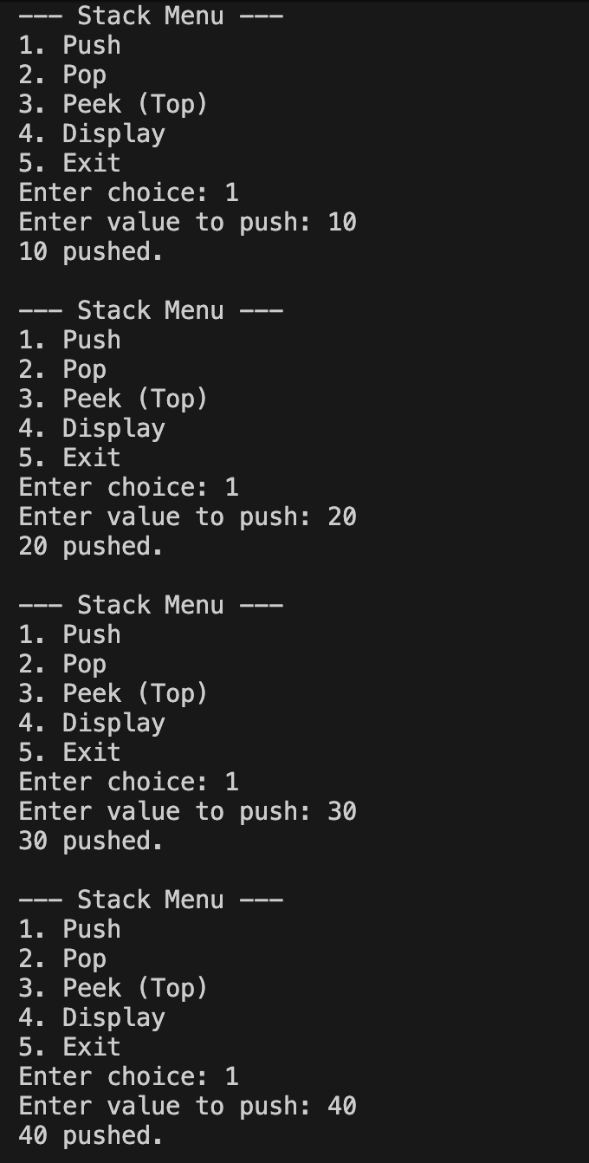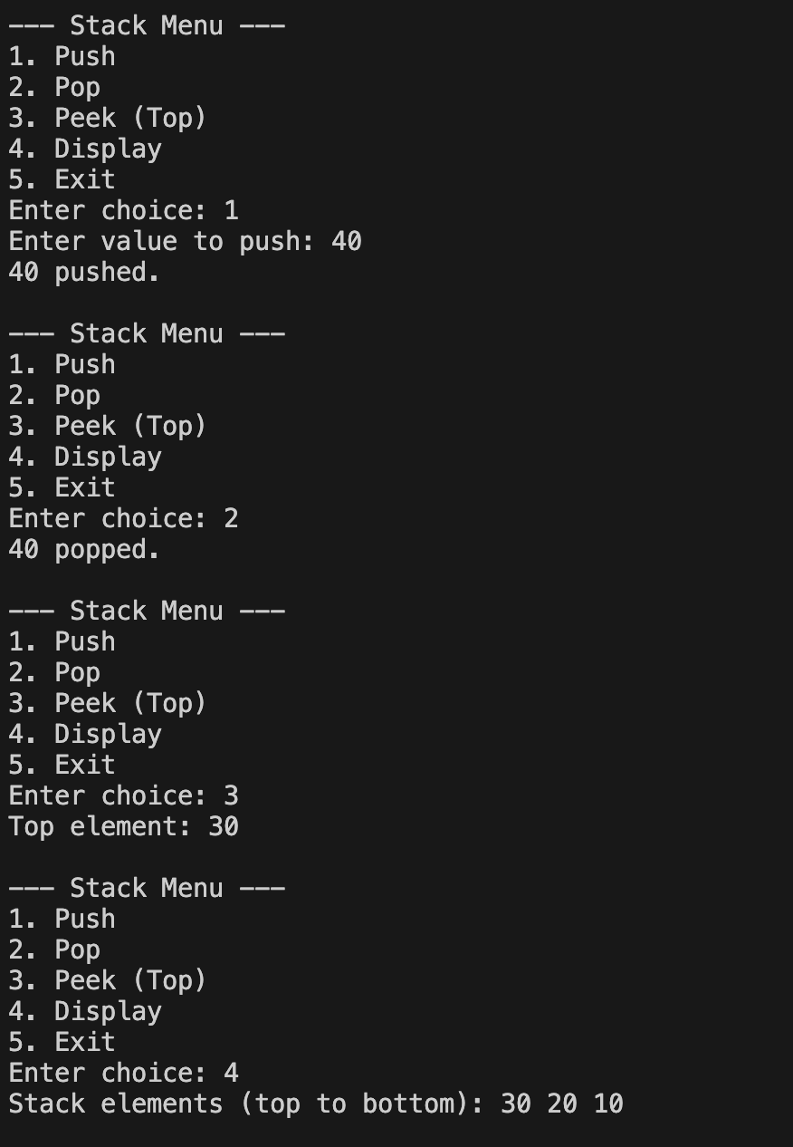

Practical no.: 3B
AIM : Write a program to convert fully parenthesised infix expression into postfix expression. Show all the intermediate results in the table format.

INPUT :
#include <bits/stdc++.h>
using namespace std;

int prec(char c) {
switch (c) {
case '^': return 3;
case '*': case '/': case '%': return 2;
case '+': case '-': return 1;
default: return 0;
}
}

bool isRightAssociative(char c) {
return (c == '^');
}

struct Stack {
char arr[1000];
int top;

Stack() { top = -1; }

void push(char c) { arr[++top] = c; }

char pop() { return arr[top--]; }

char peek() { return arr[top]; }

bool empty() { return top == -1; }
};

string Infix_to_Postfix(string s) {
s = '(' + s + ')';
Stack st;
string ans = "";

for (int i = 0; i < s.size(); i++) {
char ch = s[i];

if (ch == ' ') continue;

if (ch == '(') {
st.push(ch);
}
else if (ch == ')') {
while (st.peek() != '(') {
ans.push_back(st.pop());
ans.push_back(' ');
}
st.pop();
}
else if (prec(ch) == 0) {

ans.push_back(ch);
ans.push_back(' ');
}
else {

while (!st.empty() && st.peek() != '(' &&
(prec(st.peek()) > prec(ch) ||
(prec(st.peek()) == prec(ch) && !isRightAssociative(ch)))) {
ans.push_back(st.pop());
ans.push_back(' ');
}
st.push(ch);
}
}
return ans;
}

int main() {
string s;
cout << "Enter an Expression : ";
getline(cin, s);
cout << "Final Postfix Expression : " << Infix_to_Postfix(s) << endl;
return 0;
}
OUTPUT :
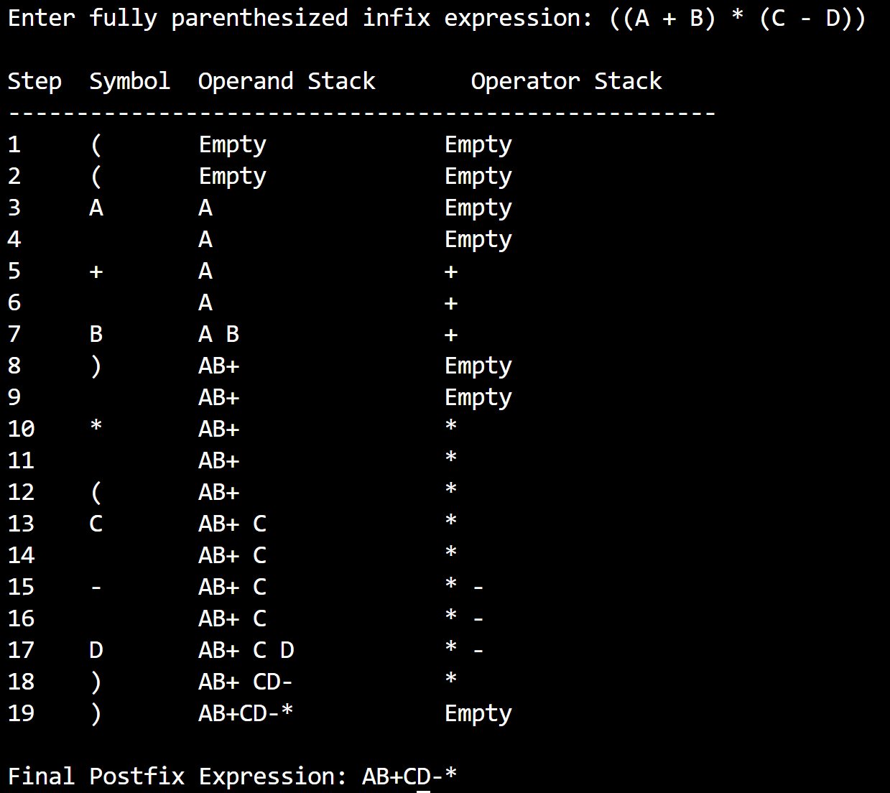

LEETCODE
- Valid Parentheses 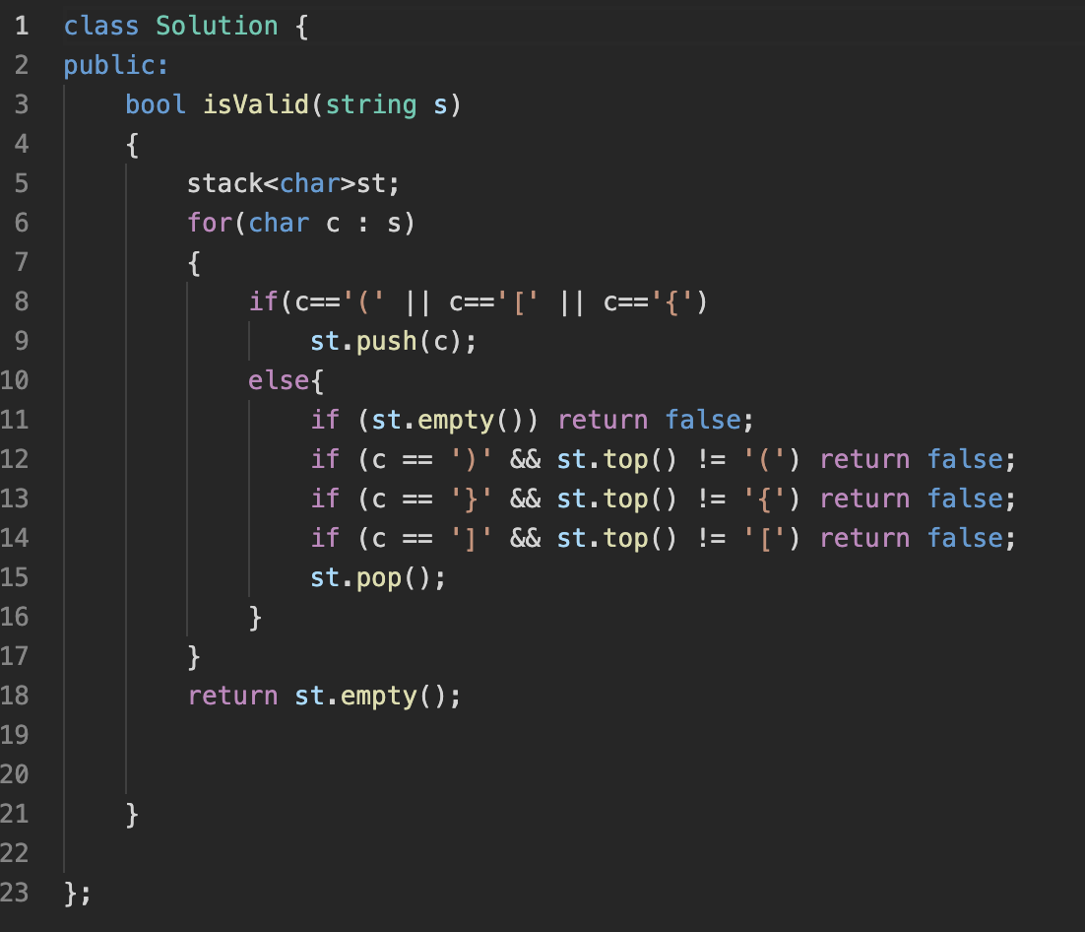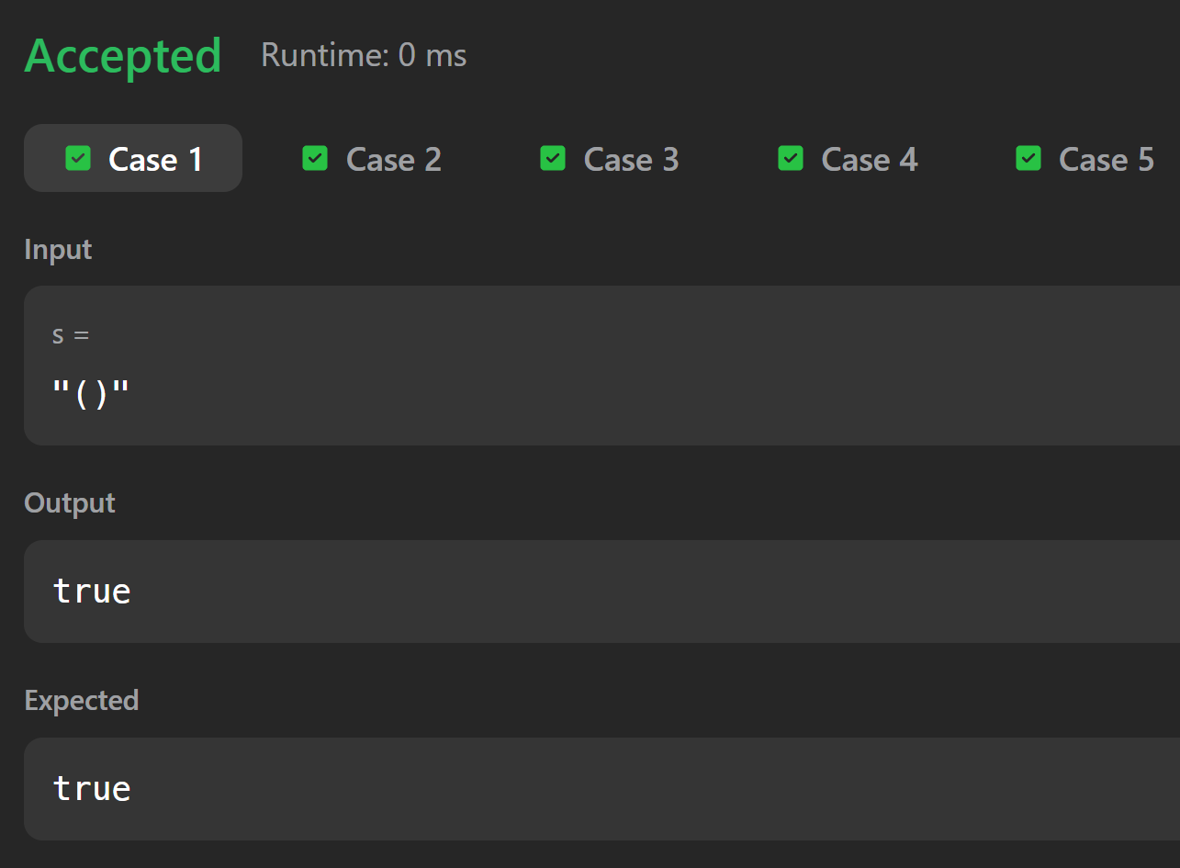

- Baseball Game
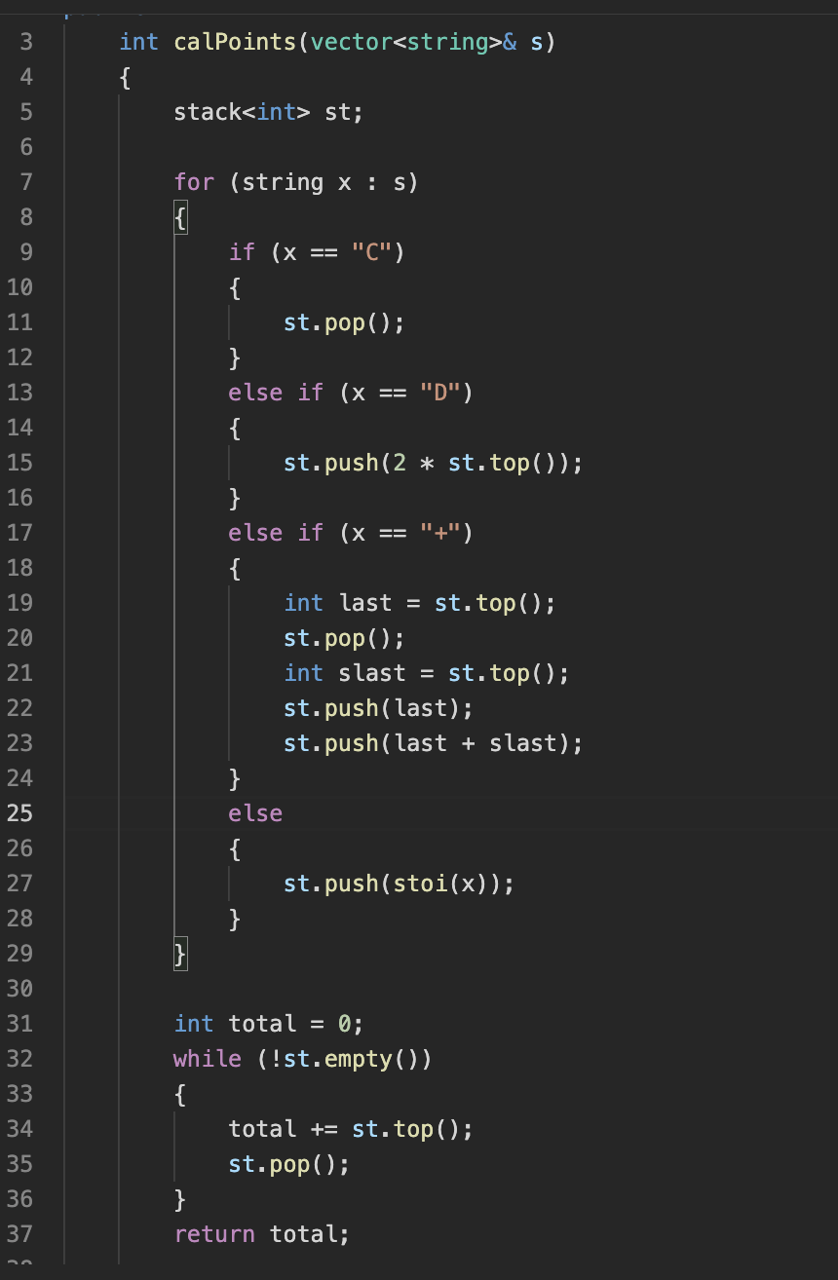
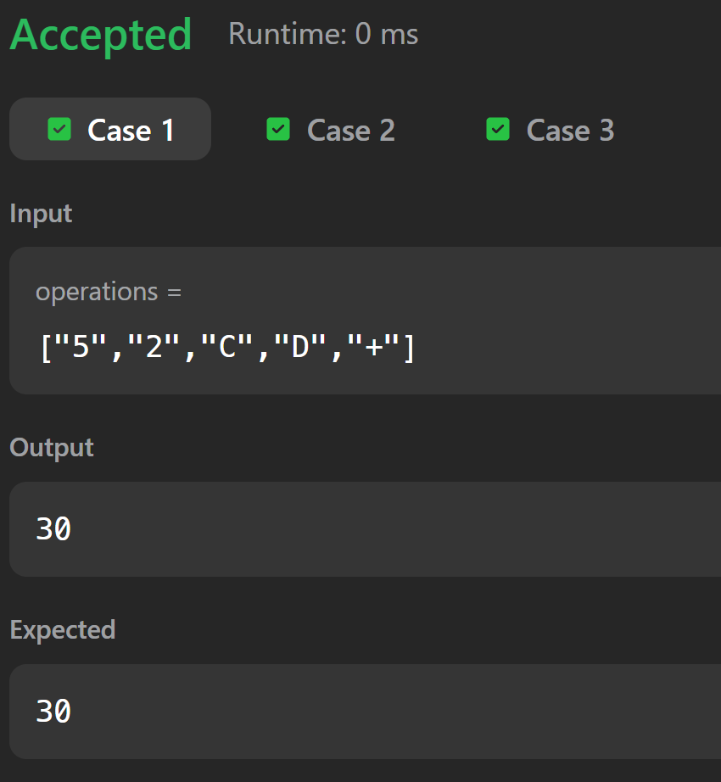

- Remove all adjacent duplicates in string 